I’ve experimented with the Ev_Initialise and this seems to run sequentially. When loading, the order that Ev_Initialise is sent is:
- Comp1::Sub1
- Comp1::Sub2
- Comp1
- Comp2::Sub1
- Comp2::Sub2
- Comp2
- (etc)

There is already an “Ev_Initialising” event which is called before. And I have now added one that calls an “Ev_PostInitialise” after. Looking at these 2 events, the sequence of events is as follows:

- Comp1::Sub1::Ev_Initialising
- Comp1::Sub1::Ev_Initialise
- Comp1::Sub2::Ev_Initialising
- Comp1::Sub2::Ev_Initialise
- Comp1::Ev_Initialising
- Comp1::Ev_Initialise
- Comp2::Sub1::Ev_Initialising
- Comp2::Sub1::Ev_Initialise
- Comp2::Sub2::Ev_Initialising
- Comp2::Sub2::Ev_Initialise
- Comp2::Ev_Initialising
- Comp2::Ev_Initialise
- Comp1::Sub1::Ev_PostInitialise
- Comp1::Sub2::Ev_PostInitialise
- Comp1::Ev_PostInitialise
- Comp2::Sub1::Ev_PostInitialise
- Comp2::Sub2::Ev_PostInitialise
- Comp2::Ev_PostInitialise

Between the “Ev_Initialising” and “Ev_Initialise”, there is a call to an internal “ProcessMsg_Initialise” C++ function (only the 3D shape actually uses this; it loads a model if required). It also does something internal to register that type of component.

After all of those, the “Ev_PostInitialise” event occurs. And after all of those, the “Ev_ChipChange” and “Ev_FCDChange” events are broadcast. Note this happens on project load only.

Adding a component does something slightly different:

- All Ev_Initialising and Ev_Initialise are processed as above (iterating through subcomponents). Note only Ev_Initialising is made to the component itself at this point.
- Ev_Adding is sent to all components
- The component is then linked to the internal data structure (presumably this has already happened in the load process)
- Ev_Initialise is then sent to the component itself
- Now Ev_PostInitialise is sent, iterating just through subcomponents
- And then Ev_PostInitialise is sent to the component itself
- Finally, Ev_Added is broadcast

Here is a set of timestamps (tickcounts) generated by some test components I has to create to work some of this out. It’s a reload of 3 components (called “Host”), and these components each contain 2 subcomponents (“Obj1” and “Obj2”). The ticks are shown for each event for “Host::Obj1”, “Host::Obj2”, “Host” in each component.

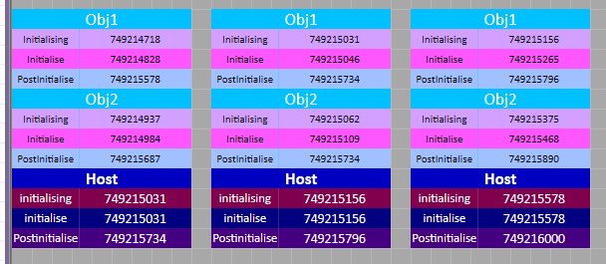

It’s a similar sequence when a new component is added, although this will have the additional Ev_Adding and Ev_Added events.

